Name Date

Algebra 1/ Geometry A- Two-Column Proofs

Vocabulary:

* A postulate is ______________________________________________________________
* A theorem is _______________________________________________________________
* A proof is __________________________________________________________________

__________________________________________________________________________

* Segment Addition Postulate: If *B* is between *A* and *C*, then . If *AB* + *BC* = *AC* then .
* Angle Addition Postulate: If *P* is in the interior of *RST*, then:

.

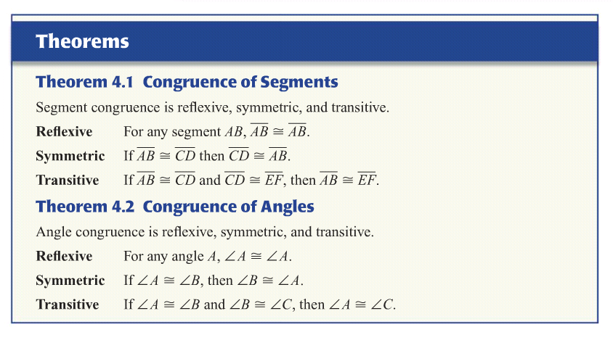

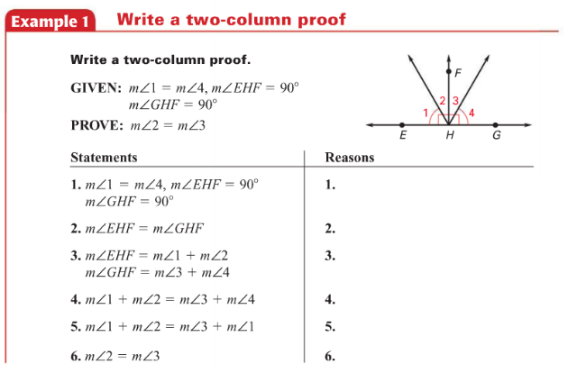

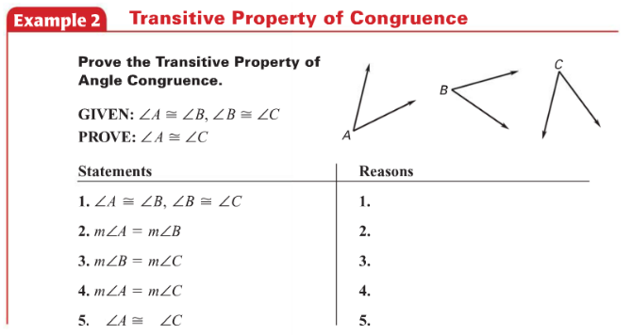

Example 3:

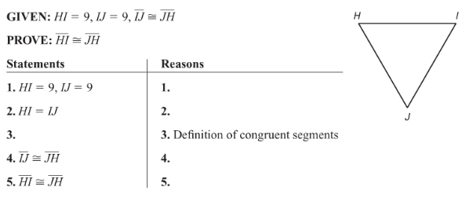

Example 4:

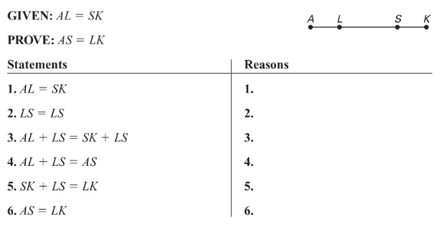

Example 5:

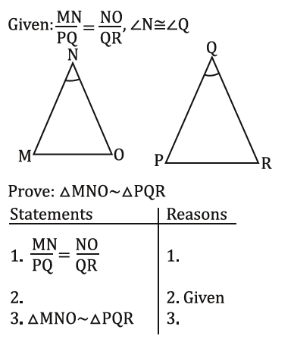

Example 6:

